Gini And Entropy

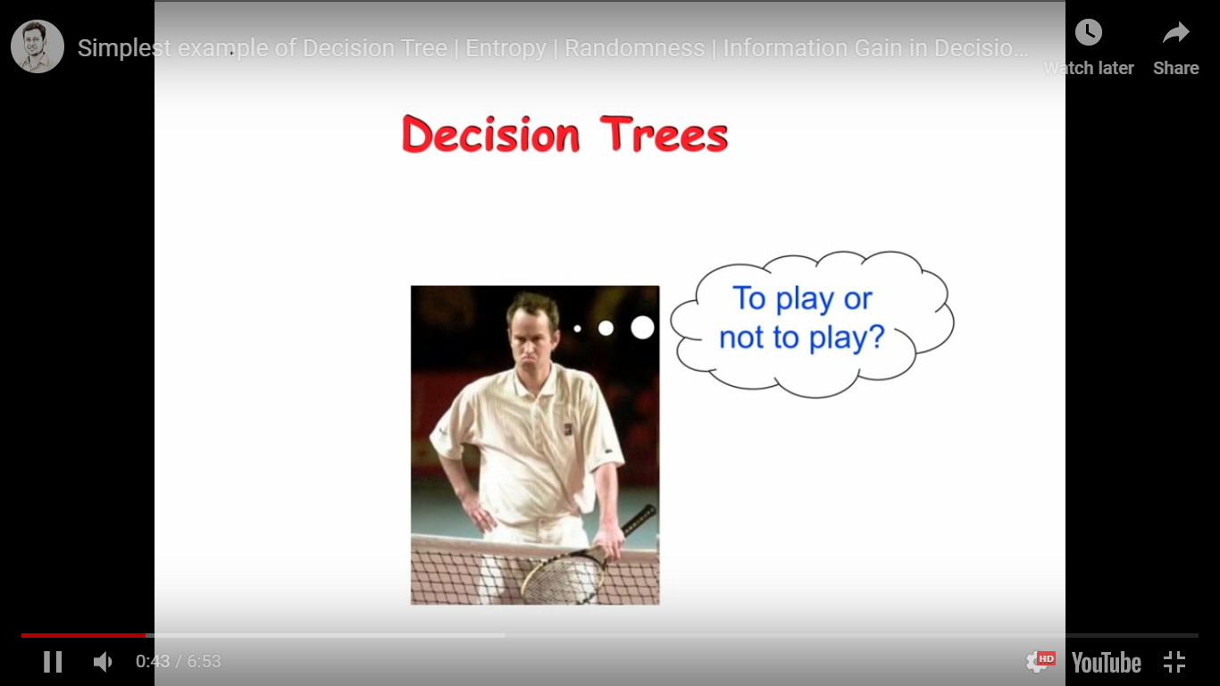

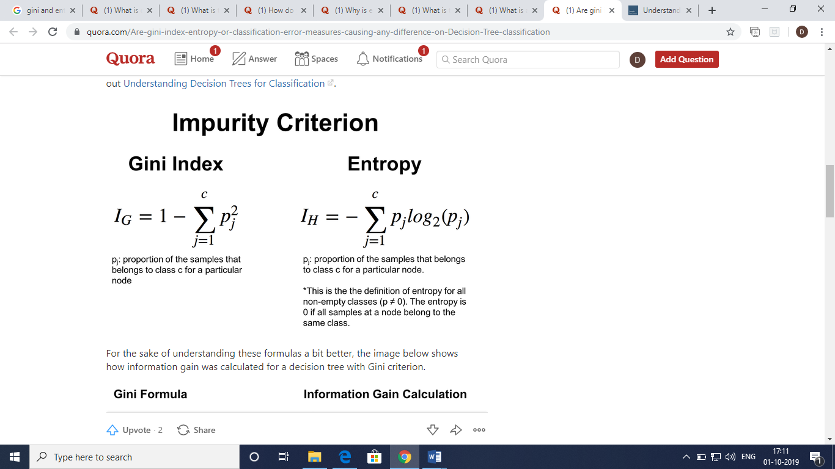

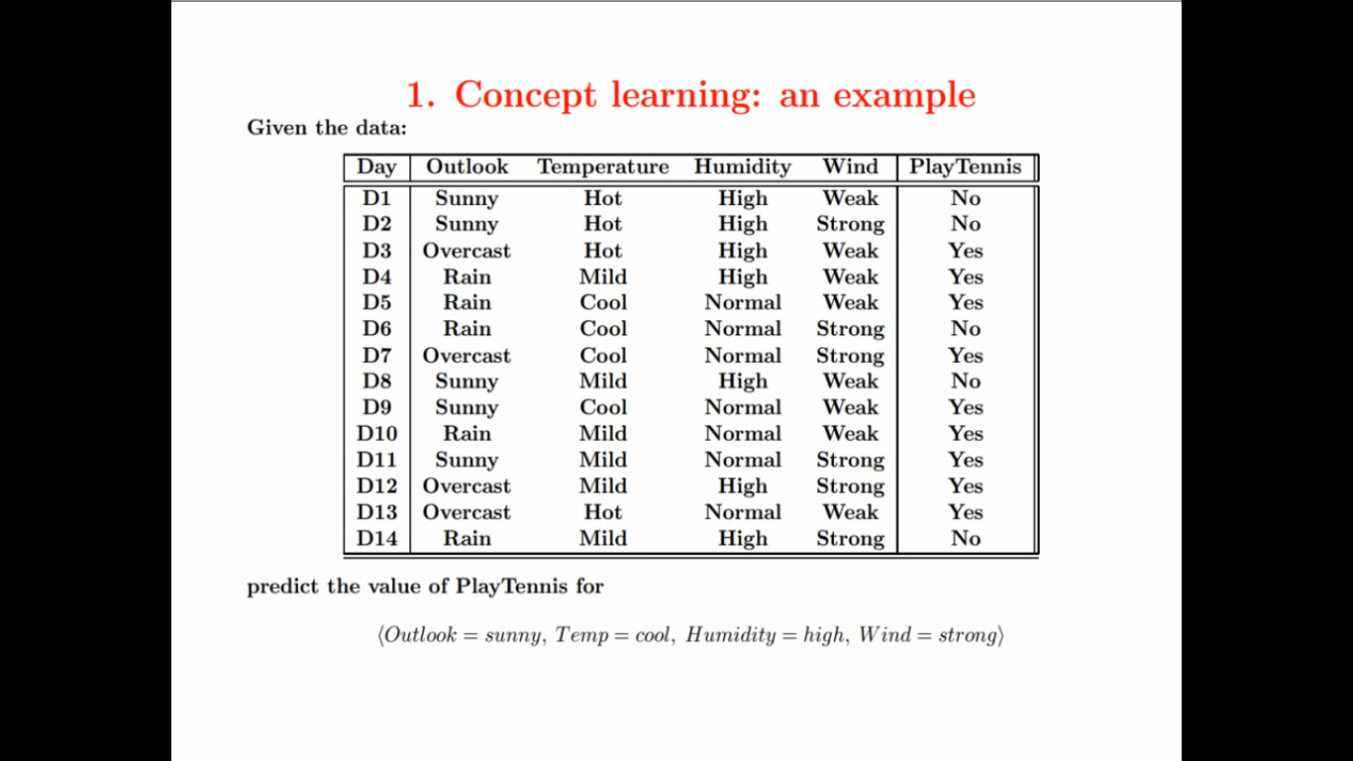

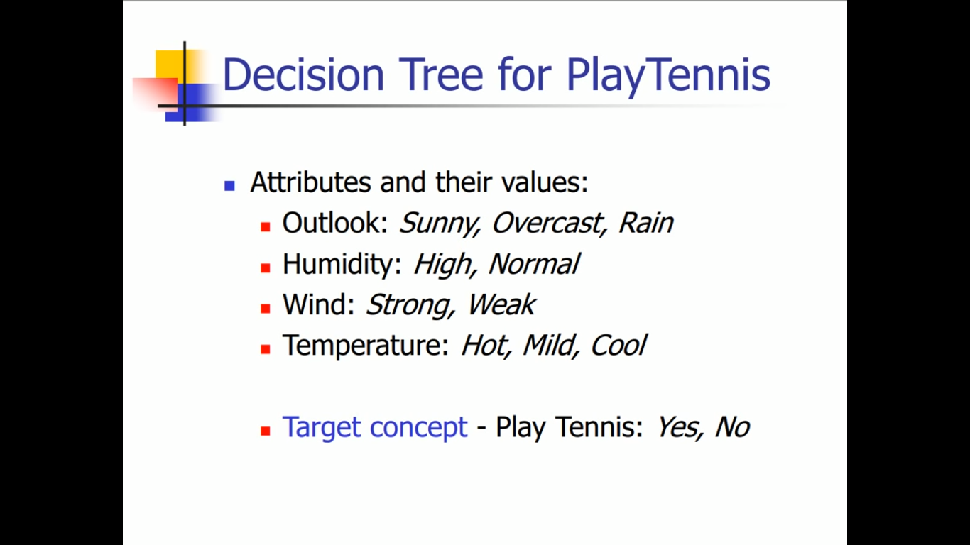

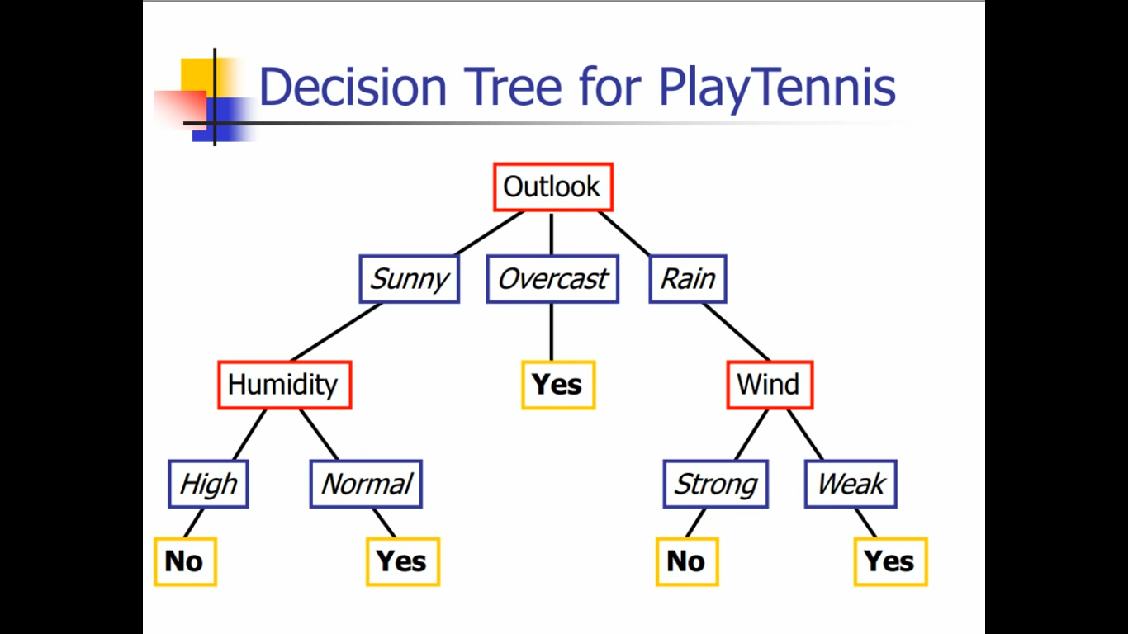

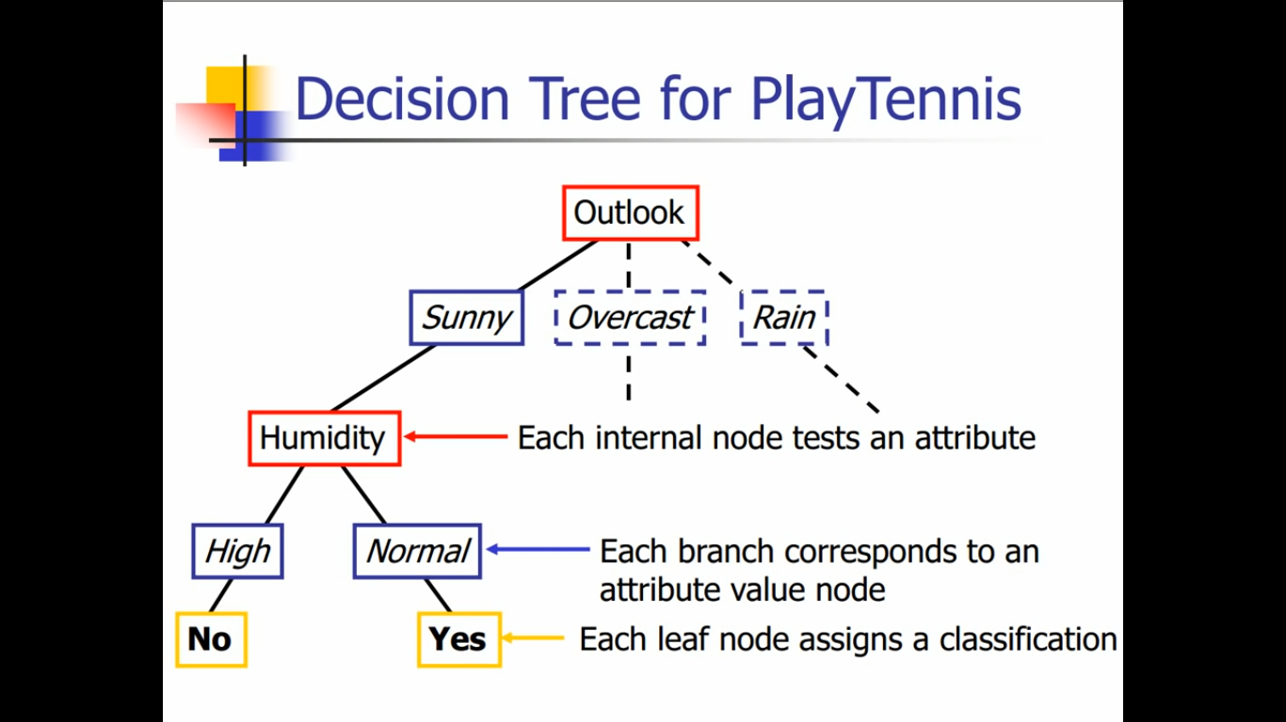

**Entropy**, as it relates to **machine learning**, is a measure of the randomness in the information being processed.

In case of diabetes dataset ,if all patients has no diabetes,

Then no information is gained ,it is 0. Or if all people diabetes then also information gain is 0 .But when

50% people has diabetes then entropy is 1.

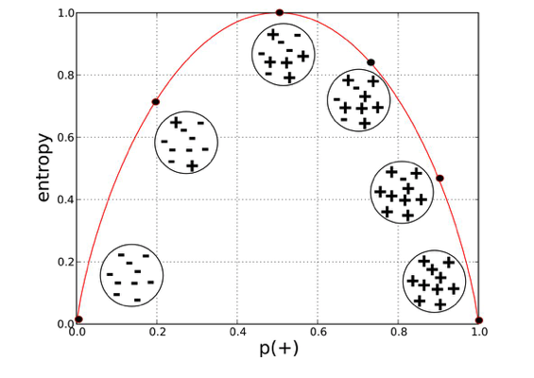

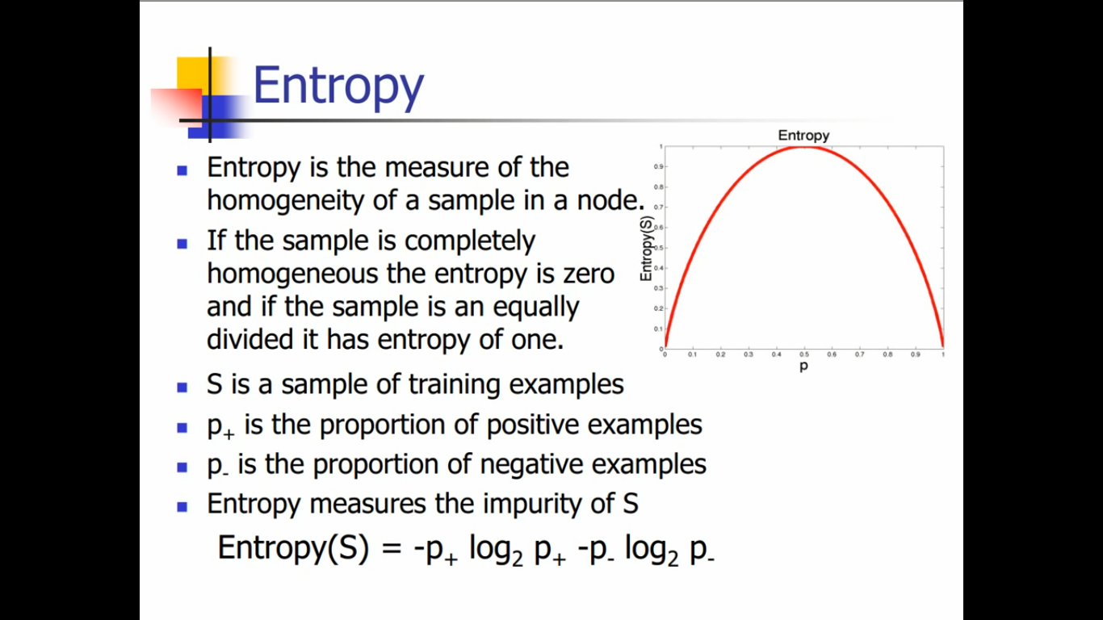

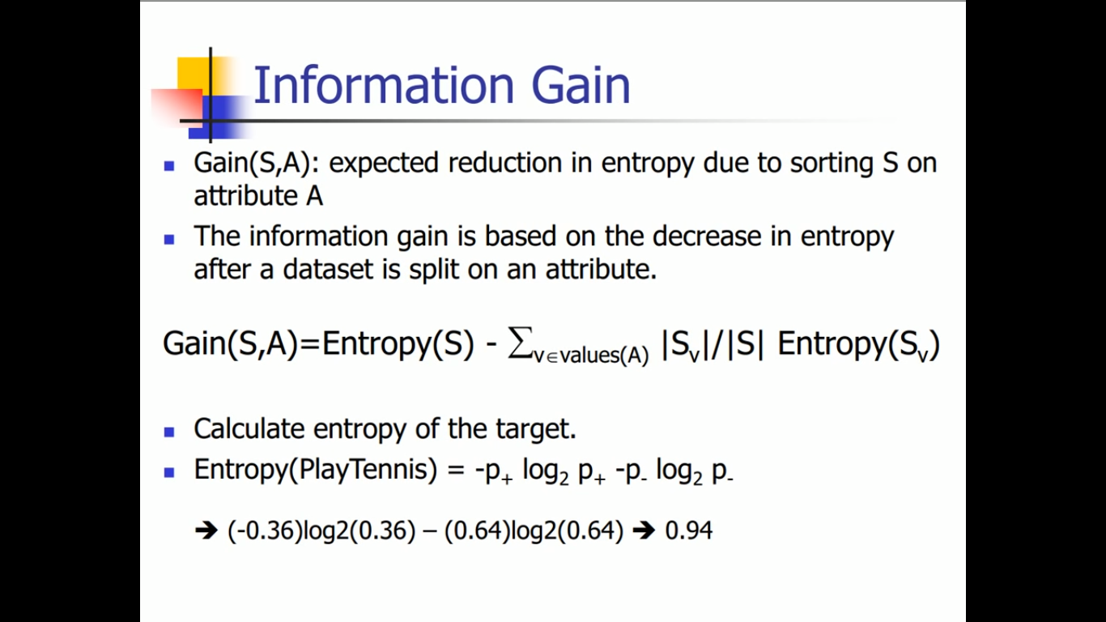

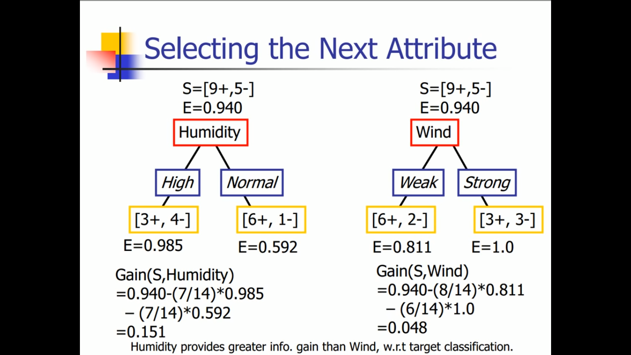

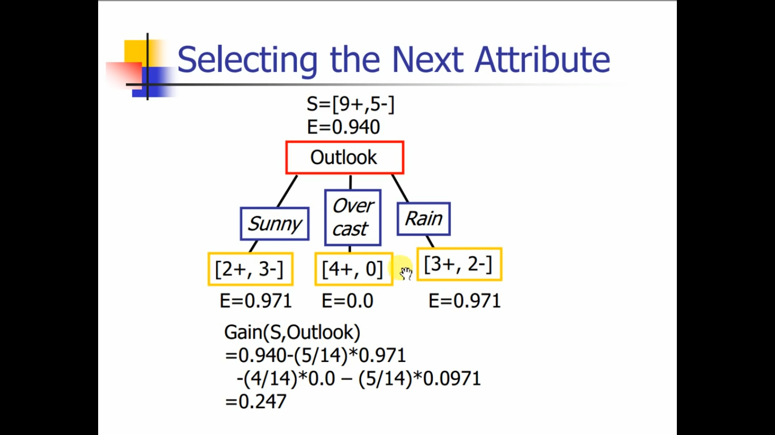

Here, overcast is 0.0 as it is very homogeneous sample.

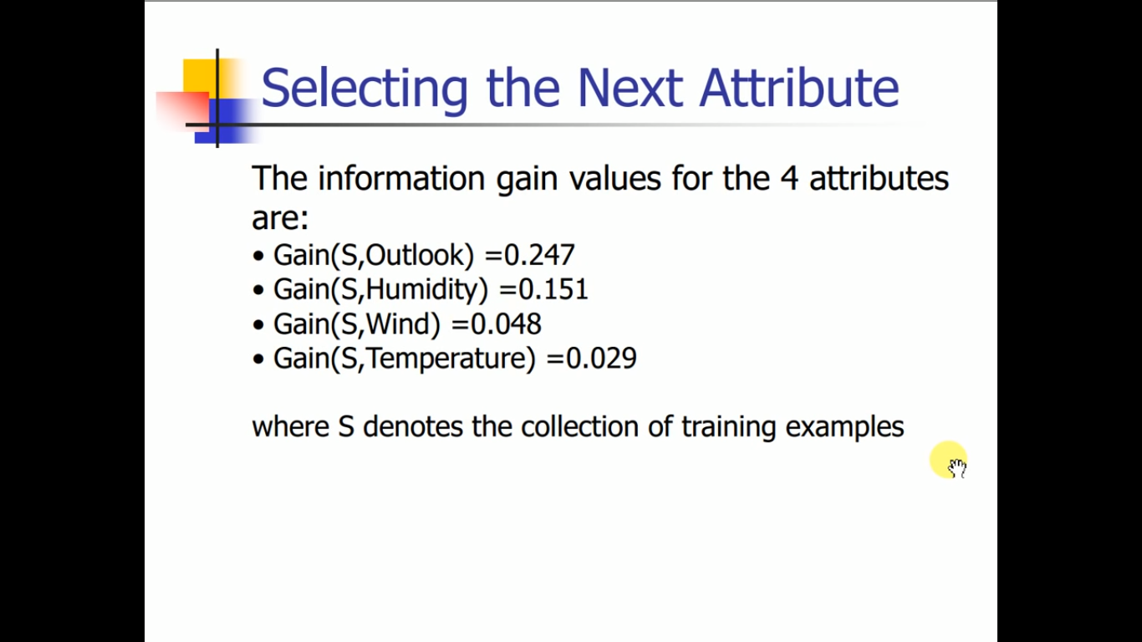

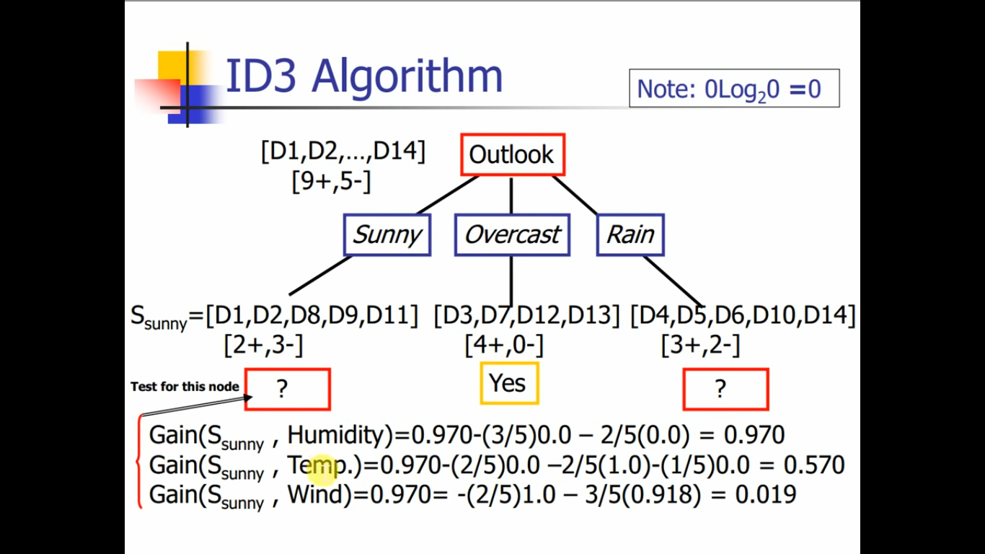

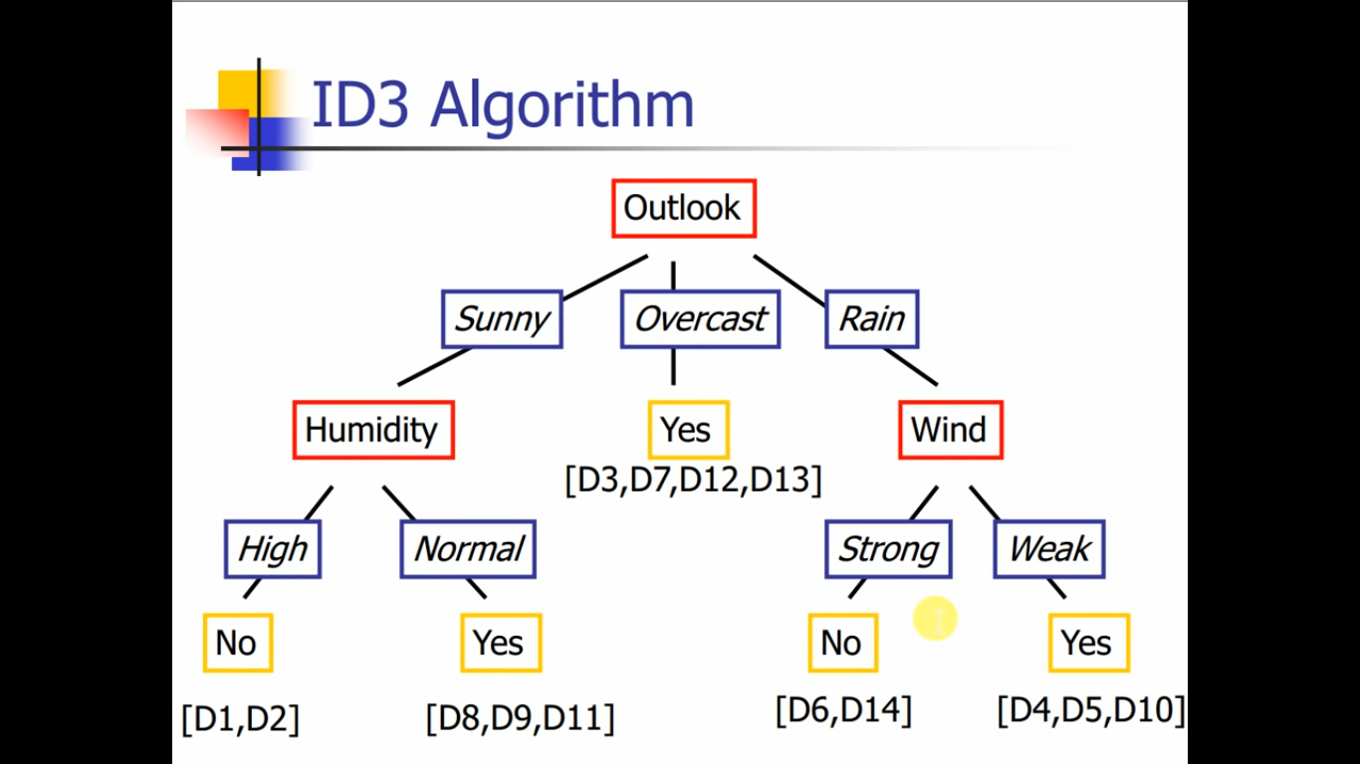

Gini Index

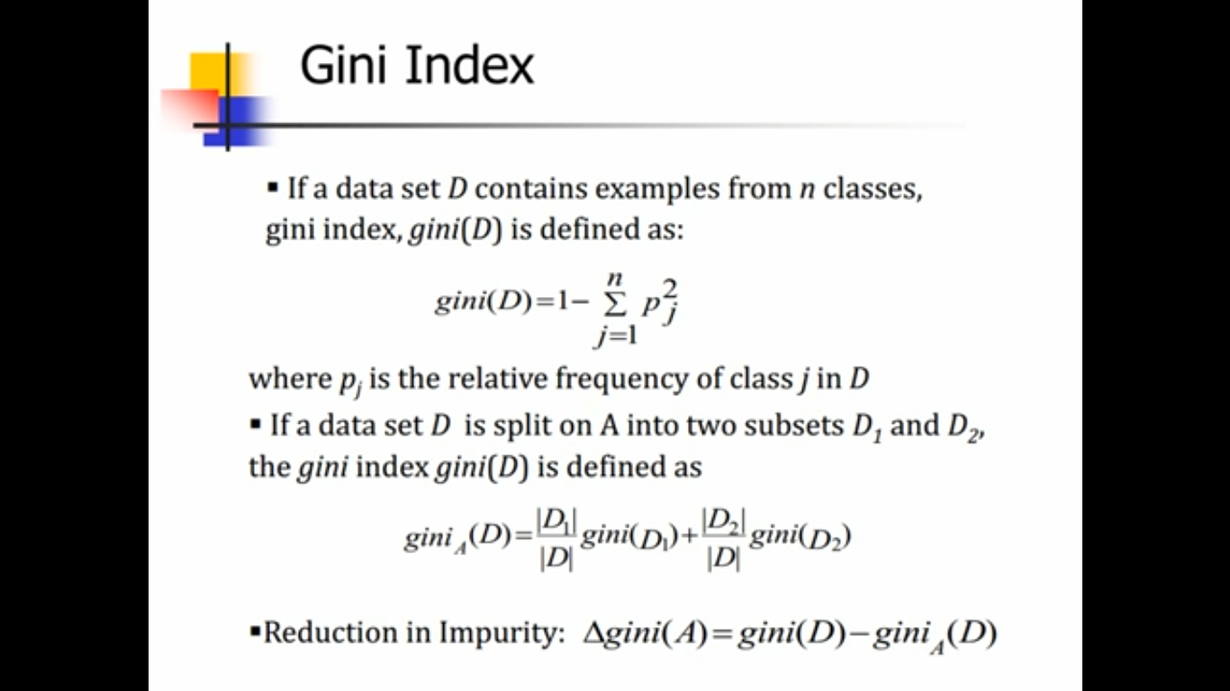

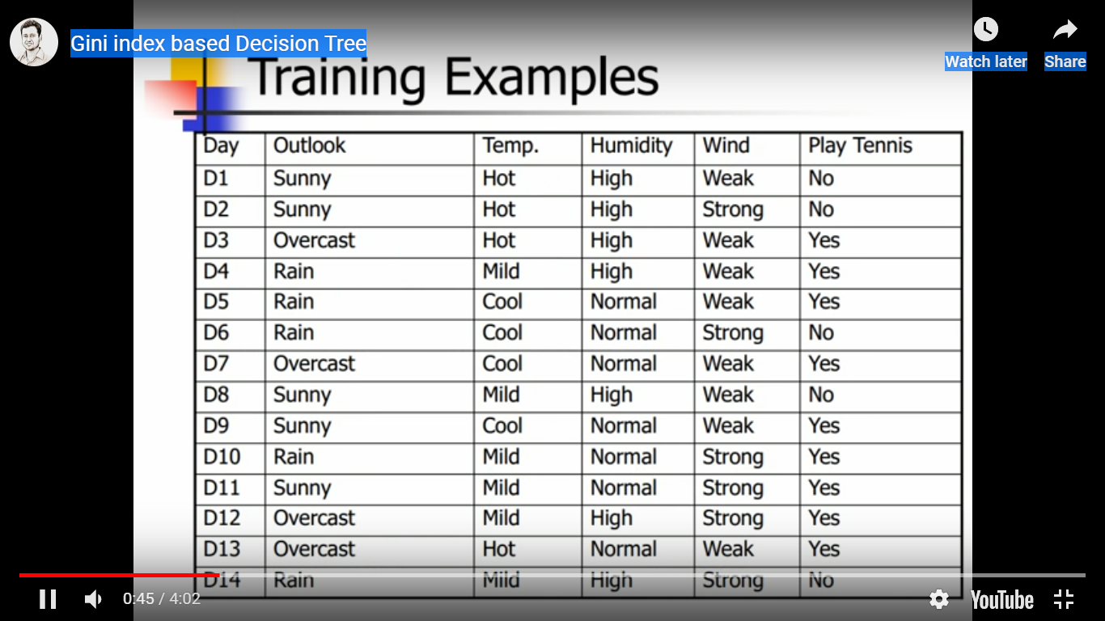

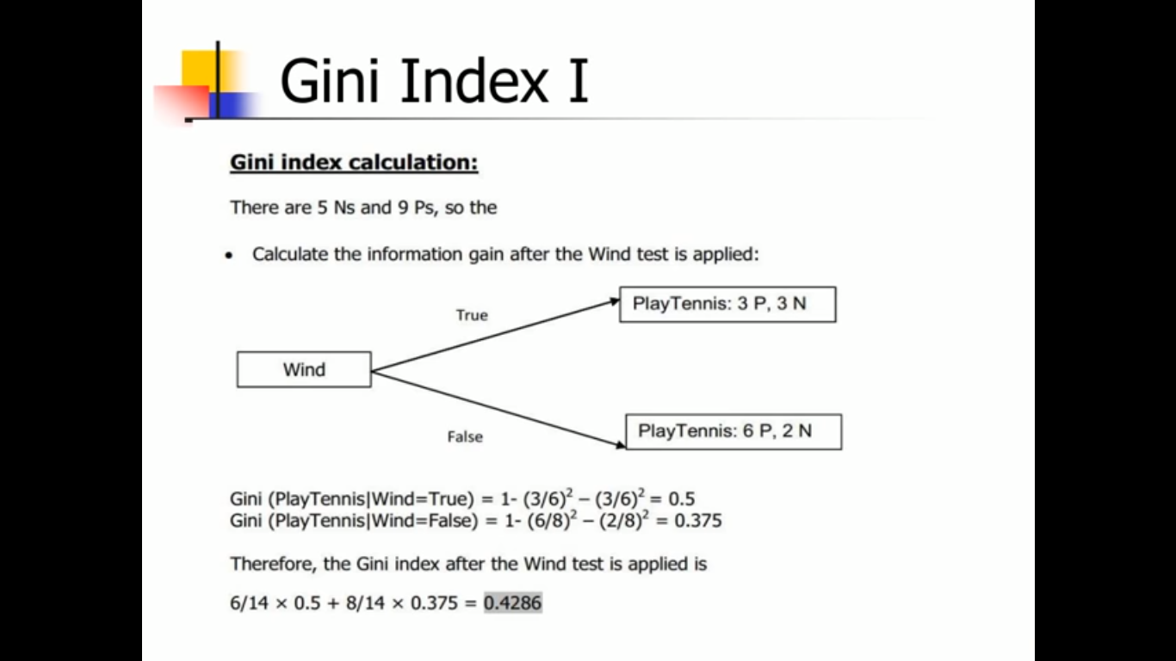

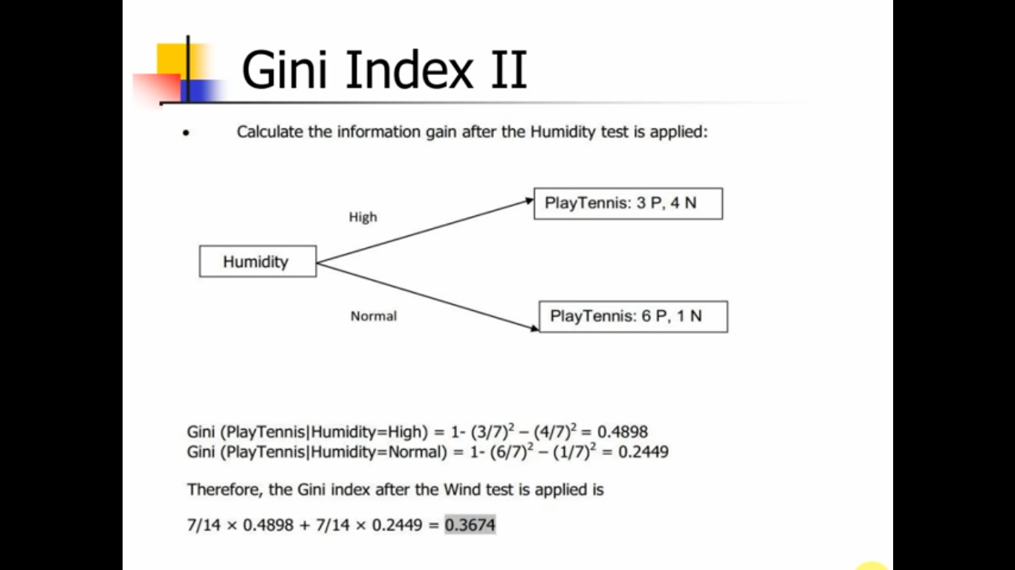

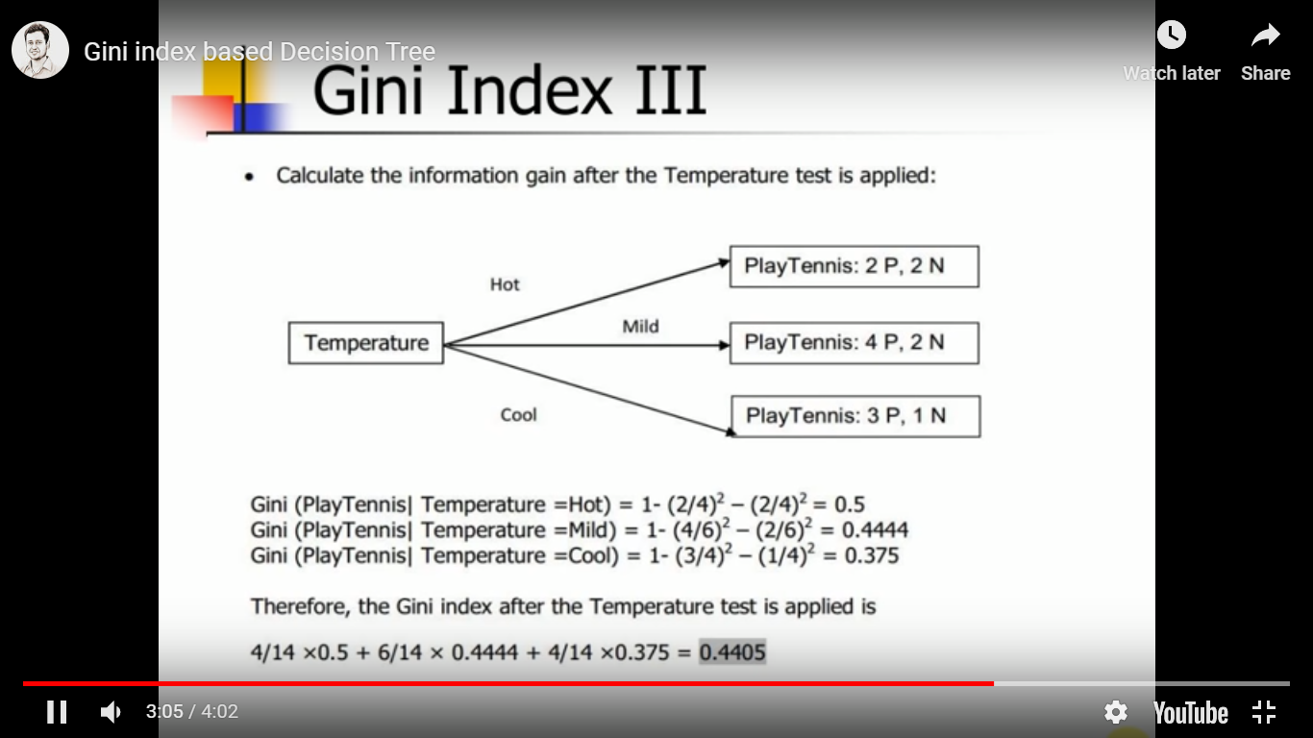

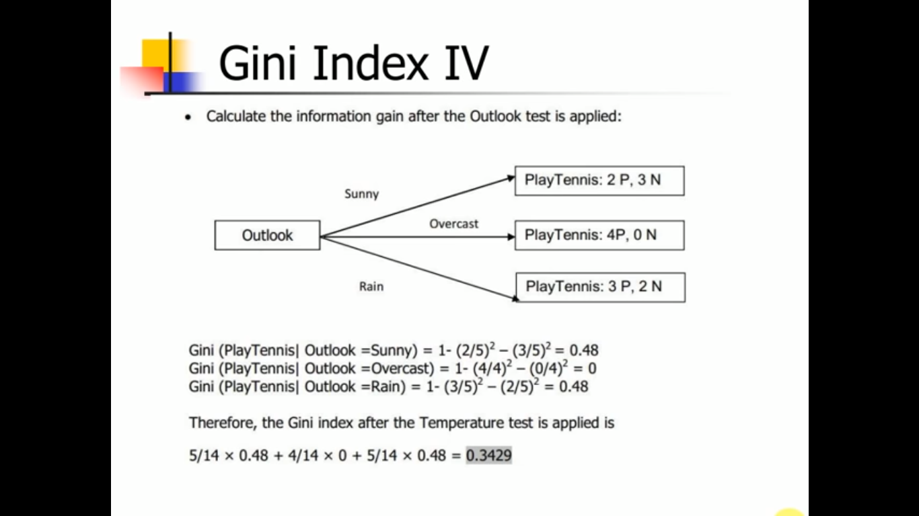

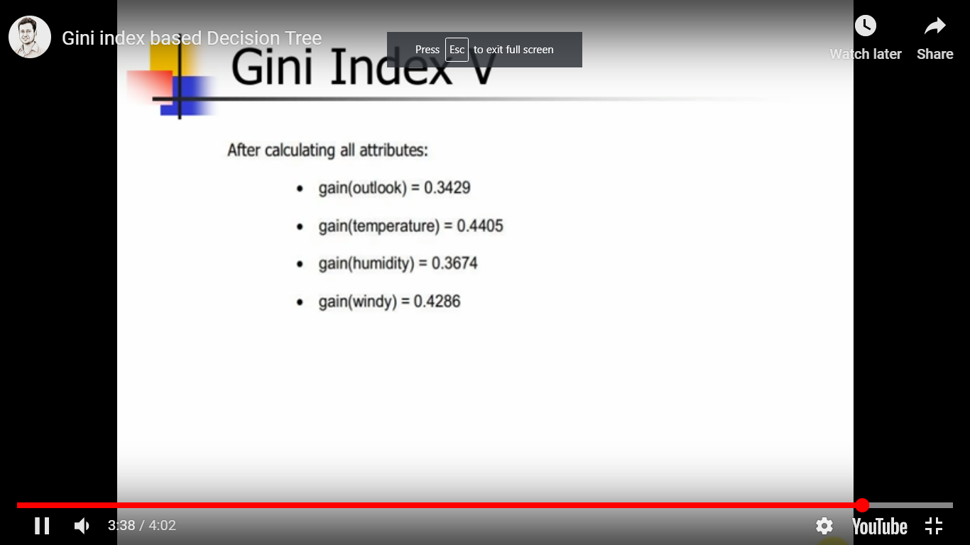

Here we are getting temperature as a highest gain 0.4405 ,hence root node will be temperature.

## Examples of SVM Kernels

Let us see some common kernels used with SVMs and their uses:

### 4.1. Polynomial kernel

It is popular in image processing.  
Equation is:

[Polynomial kernel equation](https://d2h0cx97tjks2p.cloudfront.net/blogs/wp-content/uploads/sites/2/2017/08/polynomial-kernel.png)

*Polynomial kernel equation*

where d is the degree of the polynomial.

### 4.2. Gaussian kernel

It is a general-purpose kernel; used when there is no prior knowledge about the data. Equation is:

[Gaussian kernel equation](https://d2h0cx97tjks2p.cloudfront.net/blogs/wp-content/uploads/sites/2/2017/08/gaussian-kernel.png)

*Gaussian kernel equation*

### 4.3. Gaussian radial basis function (RBF)

It is a general-purpose kernel; used when there is no prior knowledge about the data.  
Equation is:

[Gaussian radial basis function (RBF)](https://d2h0cx97tjks2p.cloudfront.net/blogs/wp-content/uploads/sites/2/2017/08/gaussian-radial-basis-function-RBF.png)

*Gaussian radial basis function (RBF)*

, for:

[Gaussian radial basis function (RBF)](https://d2h0cx97tjks2p.cloudfront.net/blogs/wp-content/uploads/sites/2/2017/08/gaussian-radial-basis-function-RBF-1.png)

*Gaussian radial basis function (RBF)*

Sometimes parametrized using:

[Gaussian radial basis function (RBF)](https://d2h0cx97tjks2p.cloudfront.net/blogs/wp-content/uploads/sites/2/2017/08/gaussian-radial-basis-function-RBF-2.png)

*Gaussian radial basis function (RBF)*

### 4.4. Laplace RBF kernel

It is general-purpose kernel; used when there is no prior knowledge about the data.  
Equation is:

[Laplace RBF kernel equation](https://d2h0cx97tjks2p.cloudfront.net/blogs/wp-content/uploads/sites/2/2017/08/laplace-RBF-kernel.png)

*Laplace RBF kernel equation*

### 4.5. Hyperbolic tangent kernel

We can use it in neural networks.  
Equation is:

[Hyperbolic tangent kernel equation](https://d2h0cx97tjks2p.cloudfront.net/blogs/wp-content/uploads/sites/2/2017/08/hyperbolic-tangent-kernel.png)

*Hyperbolic tangent kernel equation*

, for some (not every) k>0 and c<0.

### 4.6. Sigmoid kernel

We can use it as the proxy for neural networks. Equation is

[ Sigmoid kernel equation](https://d2h0cx97tjks2p.cloudfront.net/blogs/wp-content/uploads/sites/2/2017/08/sigmoid-kernel.png)

*Sigmoid kernel equation*

### 4.7. Bessel function of the first kind Kernel

We can use it to remove the cross term in mathematical functions. Equation is :

[Equation of Bessel function of the first kind kernel](https://d2h0cx97tjks2p.cloudfront.net/blogs/wp-content/uploads/sites/2/2017/08/bessel-function.png)

*Equation of Bessel function of the first kind kernel*

where j is the Bessel function of first kind.

### 4.8. ANOVA radial basis kernel

We can use it in regression problems. Equation is:

[ANOVA radial basis kernel equation](https://d2h0cx97tjks2p.cloudfront.net/blogs/wp-content/uploads/sites/2/2017/08/ANOVA-radial-basis-kernel.png)

*ANOVA radial basis kernel equation*

### 4.9. Linear splines kernel in one-dimension

It is useful when dealing with large sparse data vectors. It is often used in text categorization. The splines kernel also performs well in regression problems. Equation is:

[Linear splines kernel equation in one-dimension](https://d2h0cx97tjks2p.cloudfront.net/blogs/wp-content/uploads/sites/2/2017/08/linear-splines-kernel-in-one-dimension.png)

*Linear splines kernel equation in one-dimension*

If you have any query about SVM Kernel Functions, So feel free to share with us. We will be glad to solve your queries.